|  |  |  |
| --- | --- | --- |
| SCHOOL OF INFORMATION AND TECHNOLOGY | | |
| NAME: Hyra Cayambas | DATE PERFORMED: 09/11/24 |  |
| Section: IDC1 | DATE SUBMITTED: 09/11/24 |

# SYSADM1 – Managing Services in Linux

# Requirement:

* A virtual machine running Linux

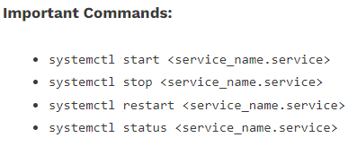

Complete this lab as follows:

Use the service –status-all command to list all active and inactive services.

List down active and inactive services in the table below. Provide five (5) services for each column.

|  |  |
| --- | --- |
| **Active** | **Inactive** |
| keyboard-setup.service | logrotate.service |
| kerneloops.service | man-db.service |
| ldconfig.service | gpu-manager.service |
| ModemManager.service | grub-common.service |
| gdm.service | getty@ttyy1.service |

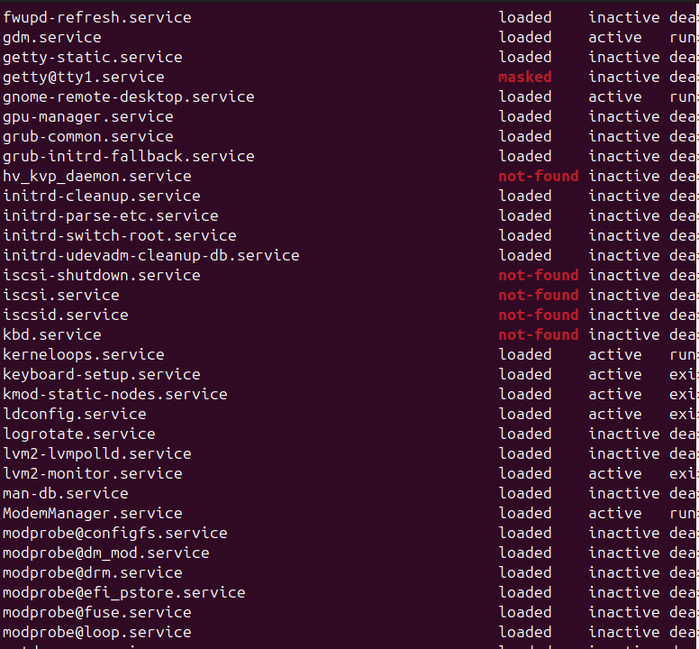SS: 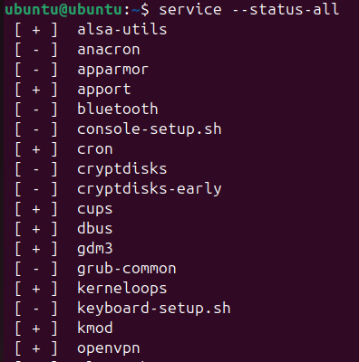

(systemctl list-units --type=service -all)

Start the Bluetooth service using the systemctl command.

Ex. sudo systemctl start httpd

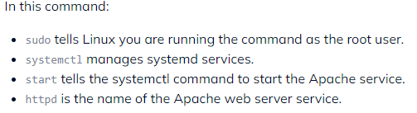

Check the status of the Bluetooth service. What is its status?

The status is inactive despite using the start command.

SS: 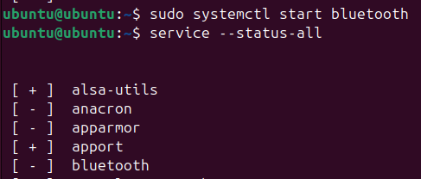

Check the status of the cups services. Since when was it running?

The cups status is active and running, the service has been running since 09/11/2024 00:07:23 UTC.

SS: 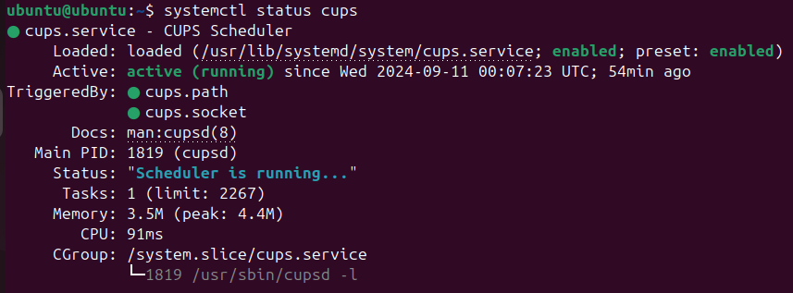

Stop cups services.



Verify if the service was stopped.

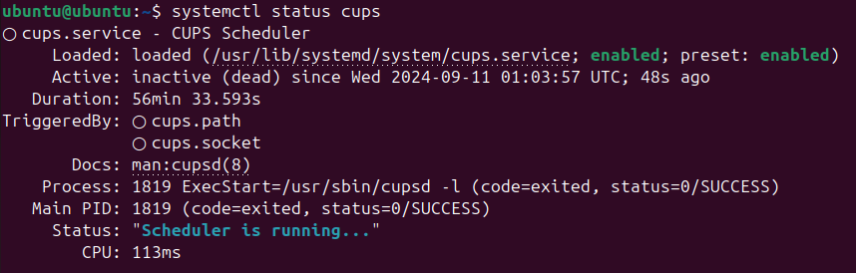

Restart the cups services

Verify if the service was restarted.

SS for 7 and 8:

